Project Development Phase
Model Performance Test

Date | 08 October 2026
Team ID | 9100Byte
Project Name | Implement Client Script & UI Policy (Incident)
Maximum Marks | As per evaluation

Model Performance Testing:
Project team shall fill the following information in model performance testing template.
S.No. | Parameter | Screenshot / Values
1. | Incident Data Rendered | 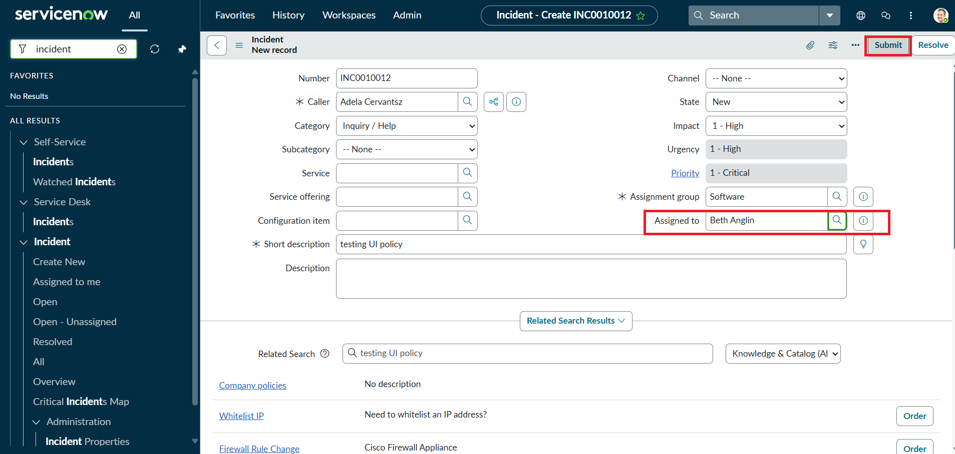
2. | Data / Form Validation | 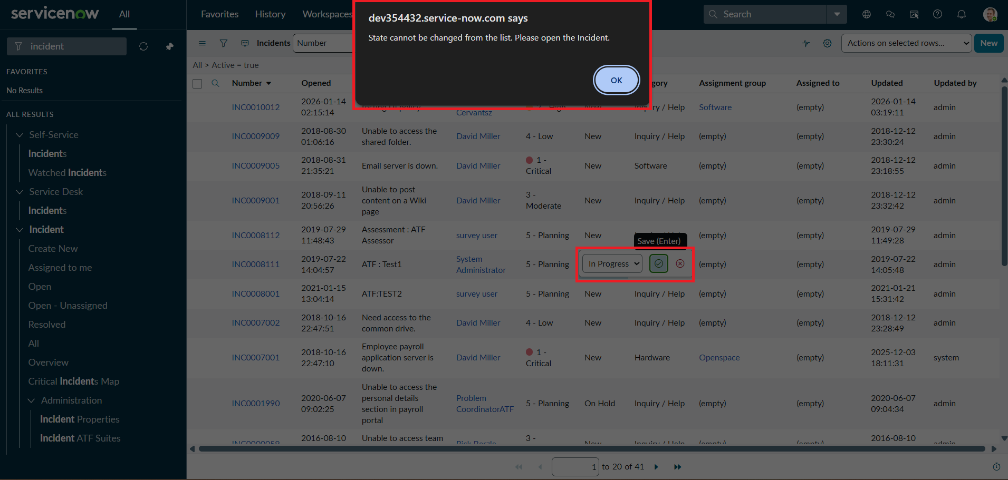
3. | Utilization of Data Filters | 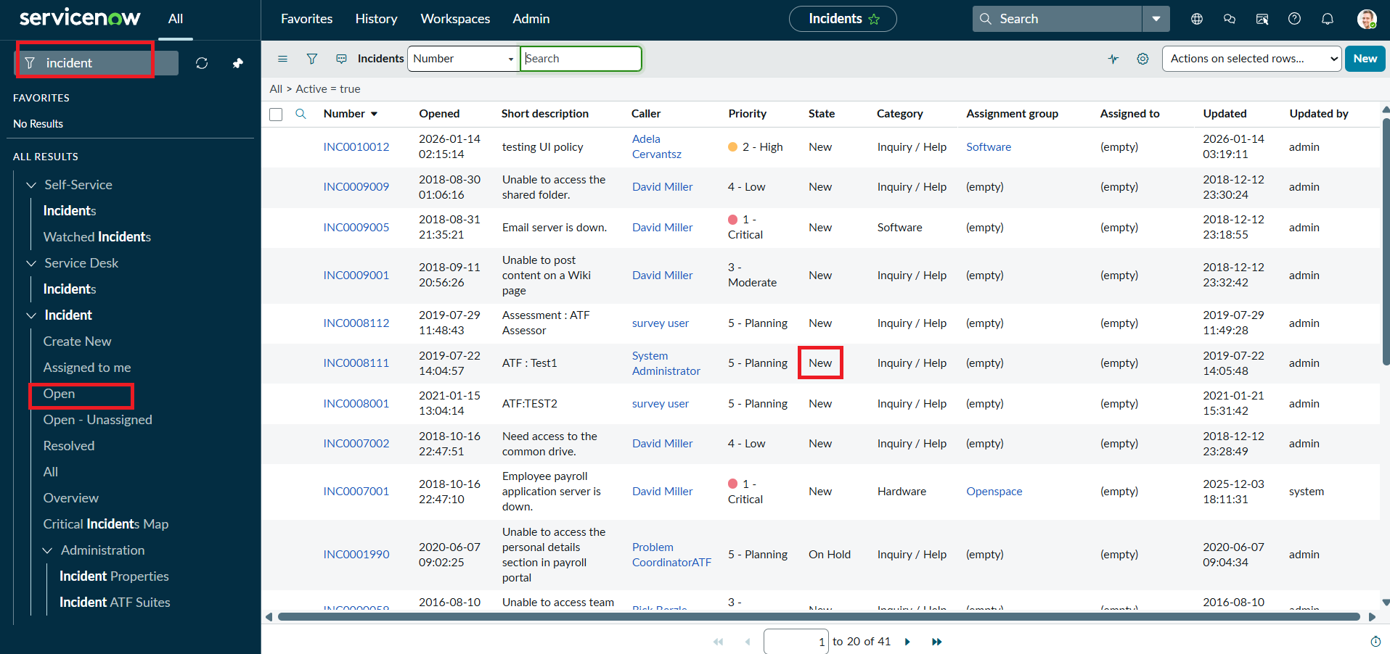
4. | Rule Logic Used | 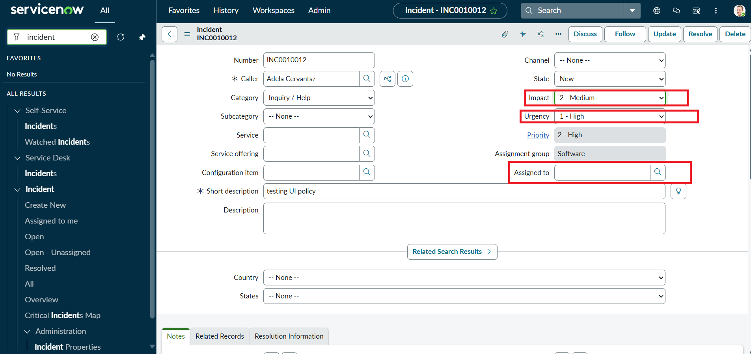
5. | Form Design | 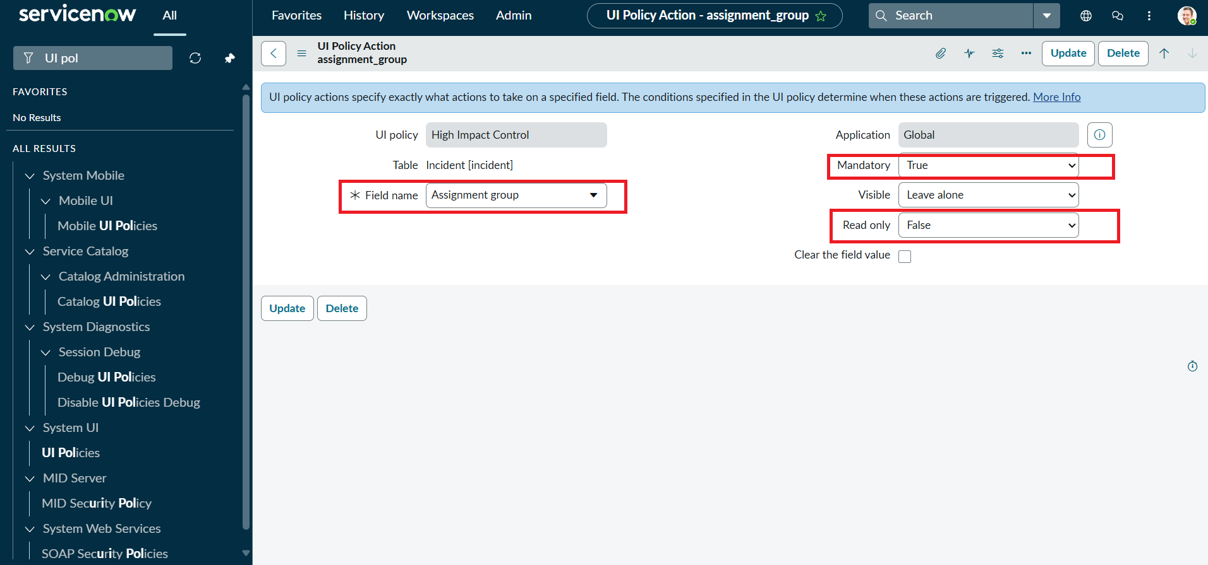
6. | Report Design | 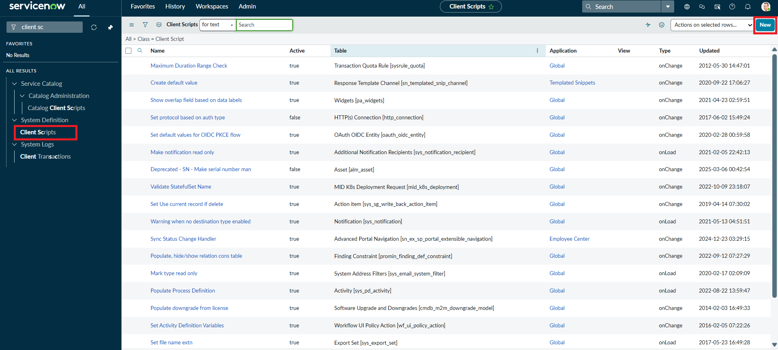

Execution Result Summary
Overall Result: PASS – implementation behavior is evidenced by the supplied ServiceNow screenshots and project document.
UAT Result: PASS – all listed functional scenarios are documented as successfully configured/verified.
Defects: None identified in the supplied evidence.
Evidence Status: Existing screenshots from the submitted implementation document have been retained and reused.
Project: Implement Client Script & UI Policy (Incident) | Team: 9100Byte | Date: 08 October 2026
Note: Power BI is not part of the implemented solution. Existing ServiceNow screenshots are retained as evidence instead of creating unrelated Power BI visuals.
ServiceNow Evidence
Evidence: Supplied ServiceNow implementation screenshot(s).
image11.png
image14.png
image13.png

